# Purpose

The Customer Support Center (CSC) Account/User Management Tool provides partners who have been granted access the ability to:

* Manage access of CSC Tools for staff and/or other partner accounts.
* Access reports associated with their organization/site(s) and/or special projects.

# Illinois workNet Roles for Those Who Enter/Maintain Data

**Super Administrators** – This role allows Illinois Works and Illinois workNet staff to approve new partner account requests, manage existing partner accounts, and view reports that drill down to partner level information in their project. Illinois Works and Illinois workNet staff identify appropriate staff for this role. Initially, Illinois workNet (IwN) Program Admin Staff assign this role. Once a person has Illinois Works Super Administrator access, they can assign roles (that are equal to or lower access) to others. They cannot assign a role higher than their own. Access to customer-level information is based upon the CSC group(s).

**Service Provider Program Administrators** – This role allows staff to approve new partner account requests, manage existing partner accounts, and view report information for their site(s). Service Provider Program Admin contact accounts, identified in the Illinois workNet Service Finder, should have these roles.

* Initially, IwN Program Admin Staff, Project, or Illinois Works Super Administrators assign this role.
* Once a person has Service Provider Program Admin role, they can assign roles (equal to or less access roles) to others. They cannot assign a role higher than their own role.
* If a Service Provider Program Admin role is combined with a CSC group (e.g., Special Project) that allows them to manage accounts in that group, they will have access to manage partner accounts outside of their organization.
* Access to customer level information is based upon the CSC group(s).

**Public Viewer Role** (Service Provider/Service Provider Manager)– This role allows staff to access partner tools and view report information for their site(s). It does NOT allow partners to approve new partner account requests or manage other existing partner accounts.

* IwN Program Admin Staff, Illinois Works Super Administrators and Service Provider Program Administrators (of that site) assign this role.
* Access to customer level information is based upon the CSC group(s).

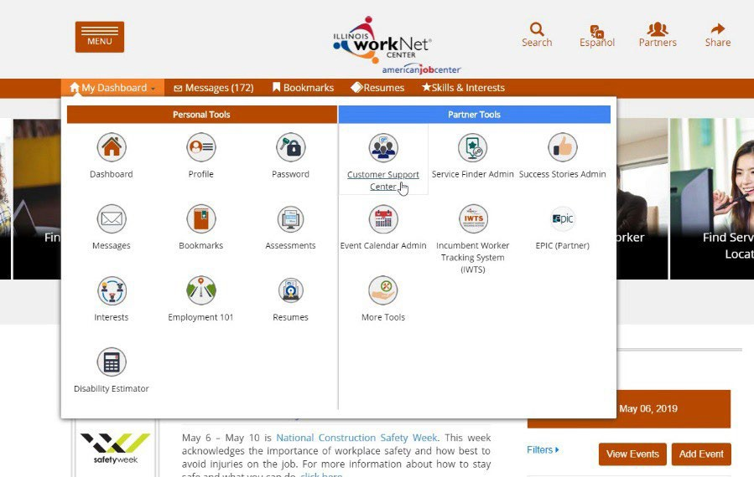

**Individual Role** – This role does not have access to partner tools.

# Access CSC/IWIS Tools

1. Log into <https://www.illinoisworknet.com/>.
2. Select My Dashboard.
3. Select Customer Support Center/IWIS.
4. Select User Management Tool icon. *The icon is the man head image in the Customer Group menu.*

# Adding a Staff Member Without an IwN Account

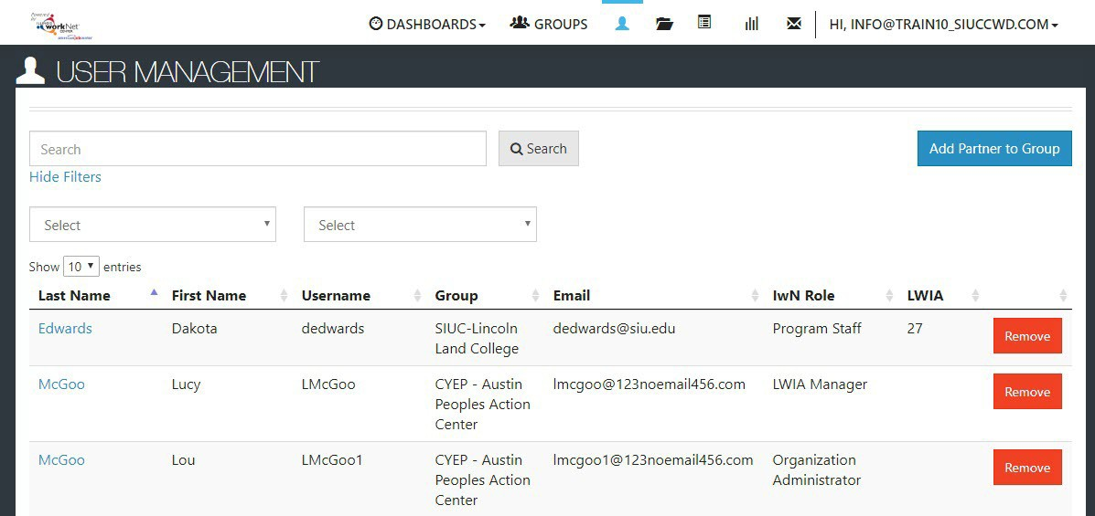

1. Search by the staff member’s name and agency to check if this user exists in the system. *See instructions in User Account was Found After Searching.*

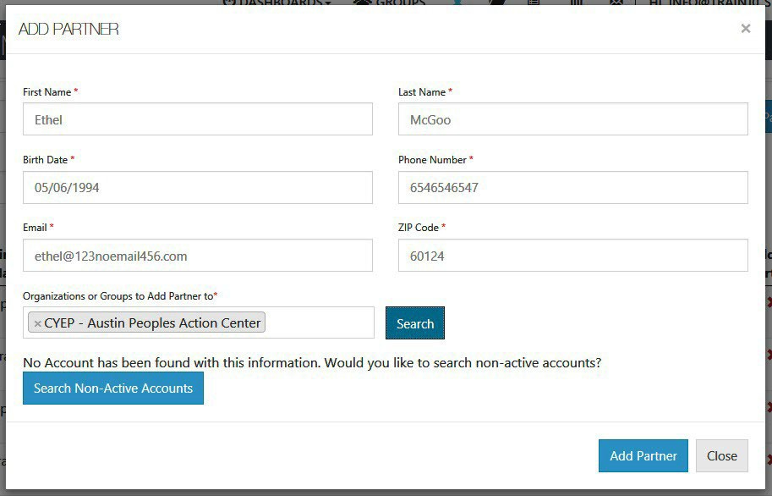

1. If the user is not found, select the Add Partner to Group blue button.
2. In the modal window that opens, enter the information about the user, including:
   1. First Name
   2. Last Name
   3. Birth Date
   4. Phone Number
   5. Email
   6. Zip Code
   7. Organization(s):

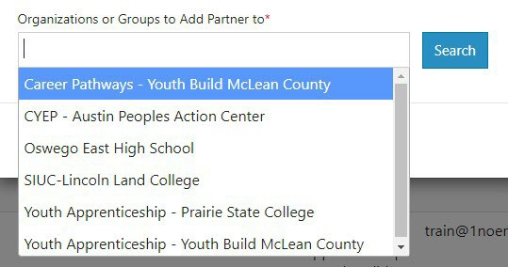

* + 1. Click the box to view a list of available organizations.
    2. Find the agency to which the partner is to be assigned. Hover to highlight the agency and click to select the appropriate agency.
    3. If adding more than one organization, click the box again, then select an additional organization, following the instructions in *ii*.
    4. Continue selecting until all appropriate agencies have been added.
    5. When all agencies have been selected, click Search.
  1. If an active account is not found, the following appears *“No Account has been found with this*



*information. Would you like to search non-active accounts?”* Click the Search Non-Active Accounts blue button.

1. If no active or non-active account is found, the following appears *“No Account has been found with this information. Would you like to create one?”* Answer Yes.
2. Does this account need to have access to view or manage this organization’s



staff? The info bubble reads: *“Yes = User will have ability to add and remove staff for their location. No = User will only see reports and customer information”*.

1. Select Add Partner.
2. At the bottom of the modal, the User Name and Password will appear. Save this information for the user. *A new Illinois workNet account has been created for the user.*

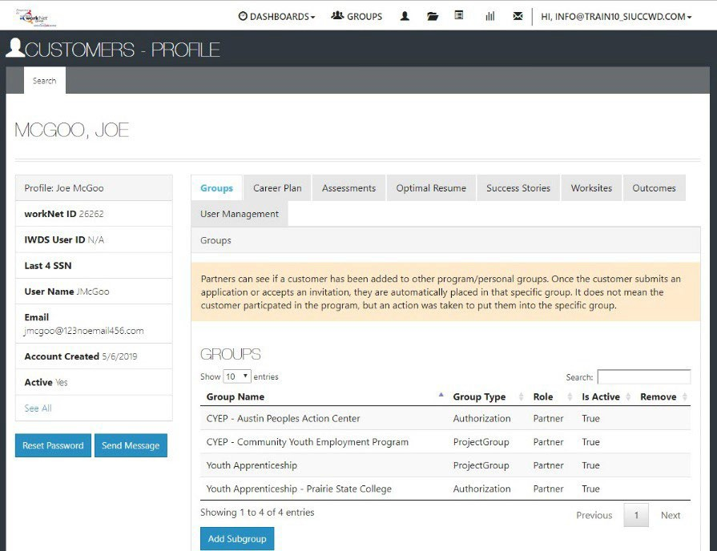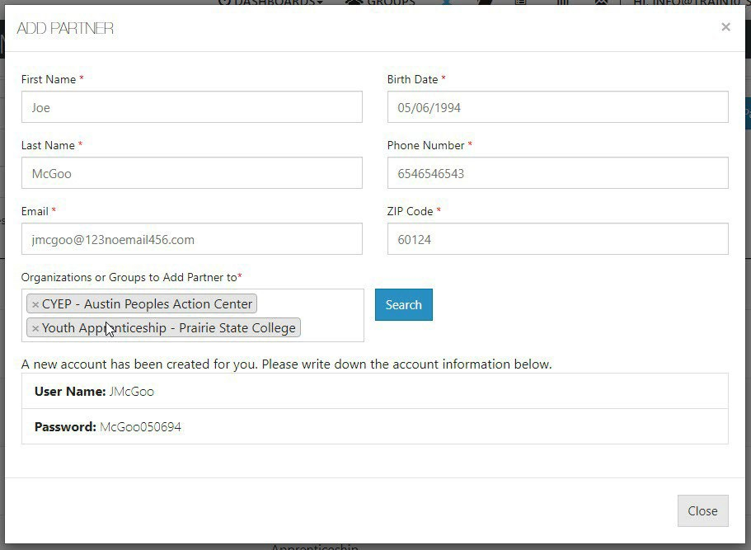

1. Close the modal window by clicking Close.
2. From the list of accounts, click on the user’s last name. On the user’s profile, click on the Groups tab to check the agencies to which the user has access.
3. Once the account is established, if user status is changed, their account can manage other users by checking the box under the *User Management* tab in their profile. Checking the box allows access to manage other users at an equal or a lower

user level.

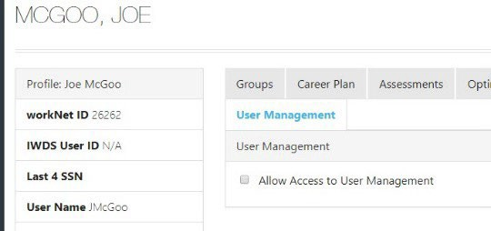

# Adding Access for Users with an

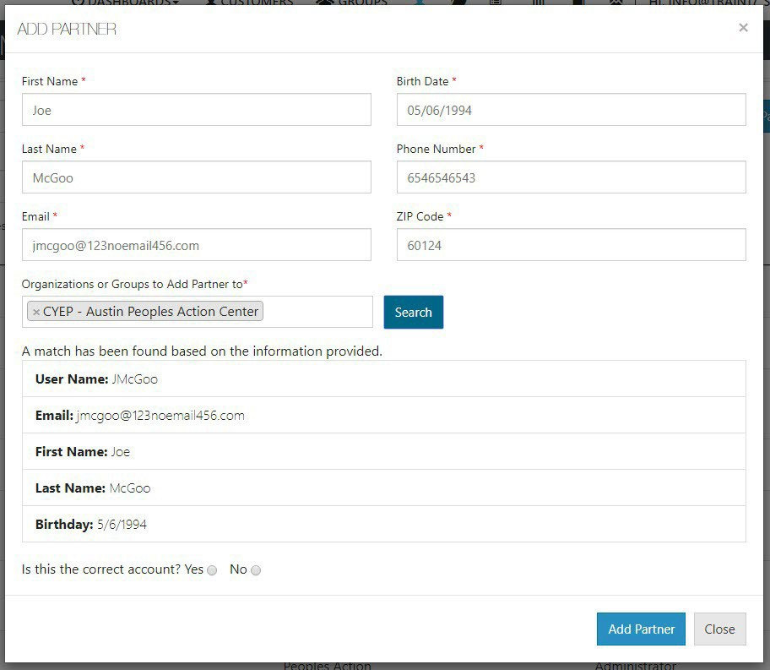

**IwN Account**

After clicking the Search button, if the user already has an account, verify that the account is correct.

1. IwN returns matches based on the search process:
   1. 1st by Email, 2nd by name and DOB, 3rd by active accounts.
   2. If no match is found in active accounts, the system will ask to Search Non-Active Accounts.
   3. If an exact match is available, select Yes. Clicking NO closes the account.
   4. If an exact match is not present, verify the information for the user

that was returned. If updates are needed (i.e. email or last name, contact the user or [info@illinoisworknet.com](mailto:info@illinoisworknet.com)).

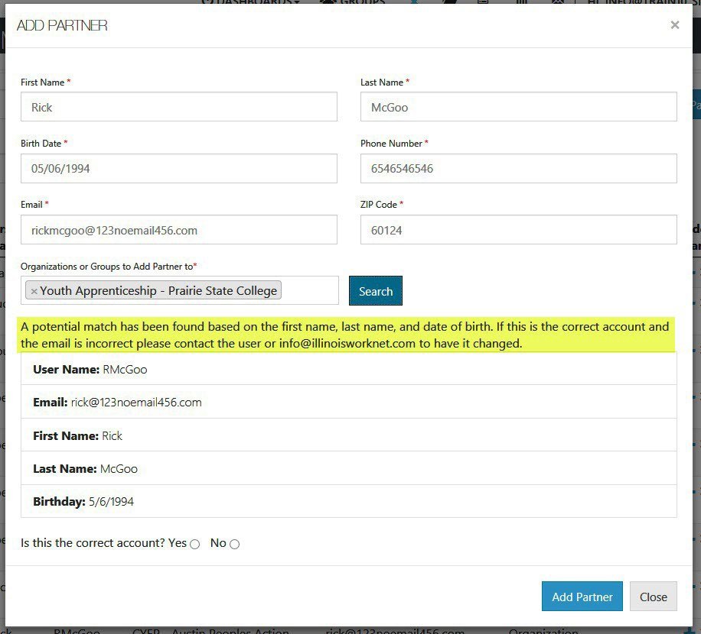

* 1. Does this account need to have access to view or manage this organization’s staff? The info bubble reads: *“Yes = User will have ability to add and remove staff for their location. No = User will only see reports and customer information.”* Answering “Yes” to this question will open the second question.

1. Select Add Partner.
2. If the user already exists in the group, a message will popup that reads “Partner Already Exists in this Group”, if not, the user will be added to the new group.



# User Account was Found After Searching

1. Click the “+” icon, in the row with the partner’s name, to Add Partner to Group. Users who are inactive will have an info bubble by the “+” and “x” icons. Once added to the group, they automatically become active again.

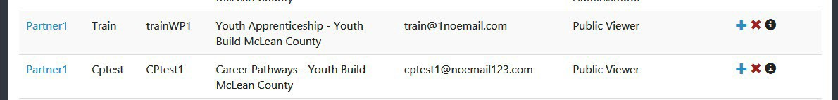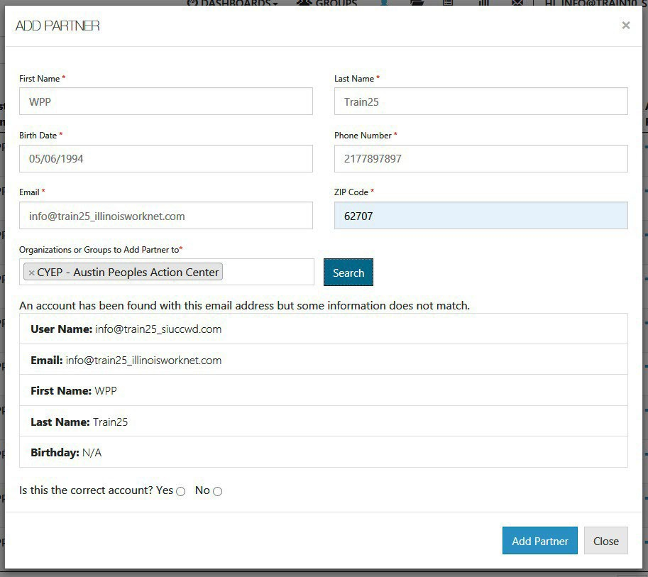

1. Information in user’s profile will autofill required fields needed for addition into the group. Complete the required fields missing information. If updates are needed (i.e. email or last name), then contact the user or [info@illinoisworknet.com](mailto:info@illinoisworknet.com).
2. Select the group(s) to which the user is to be added. Click in the box to see a list of groups from which you can select.
3. Click Search. *The results will return that some information does not match if information is missing on partner account. In this example, the Birth Date* was added.* If the account is correct, select “Yes” and continue.
4. Does this account need to have access

to view or manage this organization’s staff? The info bubble reads *“Yes = User will have ability to add and remove staff for their location. No = User will only see reports and customer information.”* Answering “Yes” to this question will open the second question.

1. Select Add Partner.
2. Verify information was properly added by clicking on the user’s hyperlinked Last Name in the list.